Instructions for Stakeholder Review of the Southwest Pennsylvania Regional ITS Architecture
Welcome to your updated (June 2023) Southwestern Pennsylvania Regional ITS Architecture! This architecture is meant to be a roadmap to guide ITS development in your region. It was developed with stakeholder input but needs further refinement. This architecture is a framework that spans all of the Southwestern Pennsylvania transportation organizations with an emphasis on the public sector. This architecture is a planning tool to help the region with integration and interoperability of its Intelligent Transportation Systems (ITS). You will see status values attached to many parts of the architecture. The status values are existing for architecture items that exist, planned for architecture items that are in planning documentation for the next 5 years and future for those architecture items that are more of a wish list for the future enhancements to the region’s ITS. The Southwestern Pennsylvania Commission (SPC) as the region’s MPO (Metropolitan Planning Organization) has taken the responsibility to develop, maintain and host this architecture but we need your help reviewing it for consistency and completeness.
Please review your applicable parts of the architecture by going to the location of the Southwestern PA Regional ITS Architecture hyperlinked website, currently at http://local.iteris.com/spc/index.htm . If you find discrepancies based on your understanding of your ITS services and inventory elements, you can select the bottom of the website link to email your comments to Josh Spano (SPC) or call him at 1-412-391-5590 x362.

Stakeholders Page
Select “Stakeholders” from the left-hand menu. You should see a Stakeholders heading along with a table listing the region’s stakeholders alphabetically with a brief description for each stakeholder. Scroll down to your stakeholder name(s) and review the description as it applies to your organization and its relationship to your ITS capabilities.
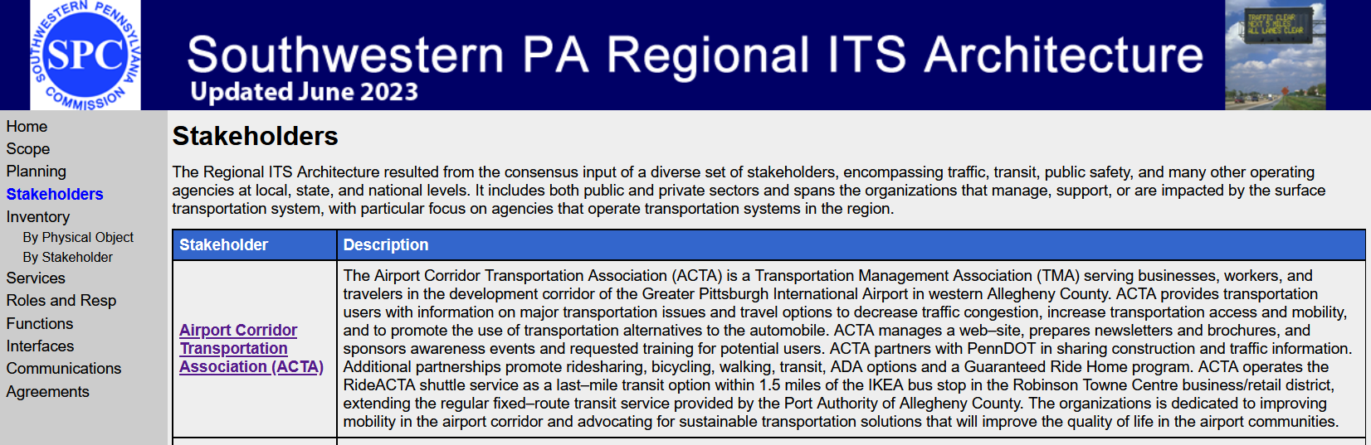

Inventory Pages
From the left-hand menu, select “By Stakeholder” under the “Inventory” menu item. You should see an “Inventory by Stakeholder” heading followed by a table listing the Stakeholders alphabetically along with a list of Elements for that Stakeholder. The Elements are the ITS Architecture Inventory that are owned/operated/maintained by the Stakeholder. Scroll down to your stakeholder name(s) and select each Element.
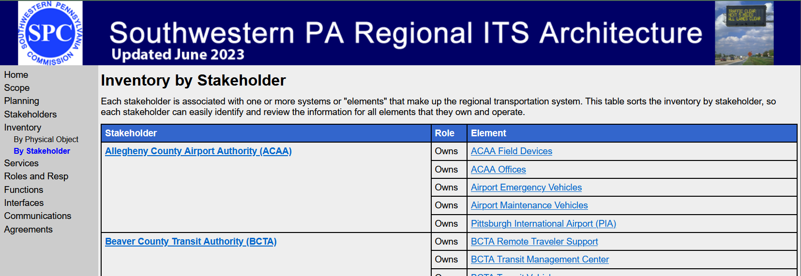
For each Element review the name of the element, the status of either existing, planned or future, a brief description describing the inventory element, the general functionality of the element and verify that the interfaces to other elements are correct.
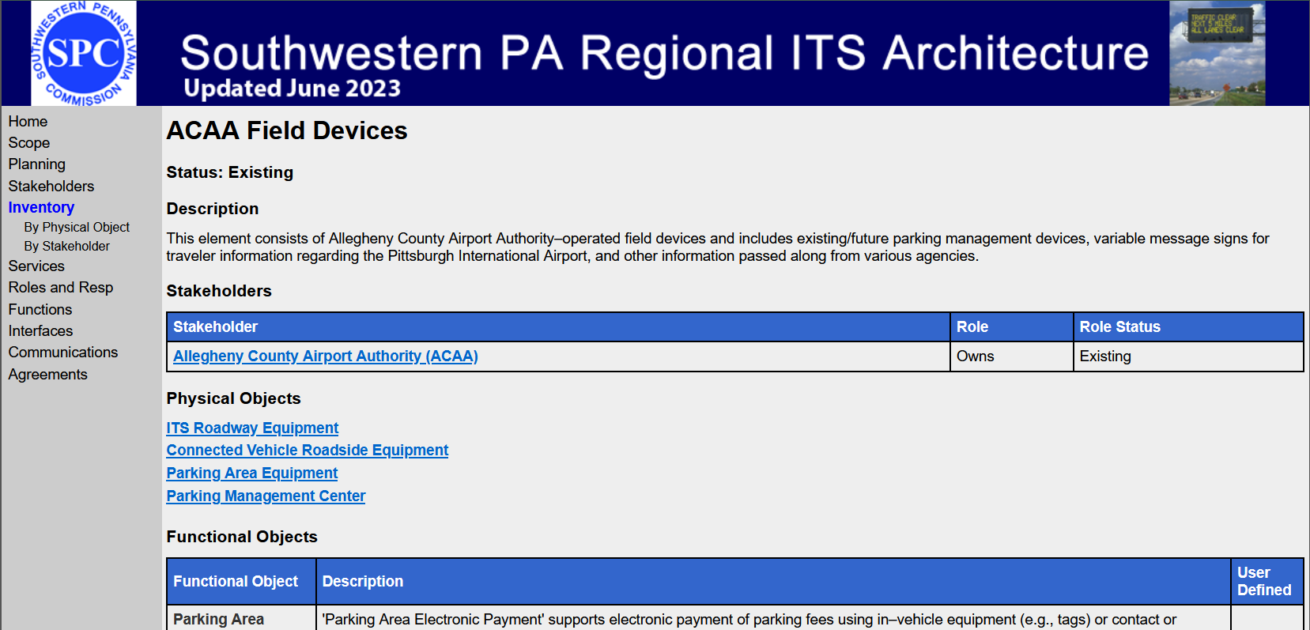
Next, review the graphical representation of the context diagram for your element by selecting the “(View Context Diagram)” hyperlink.
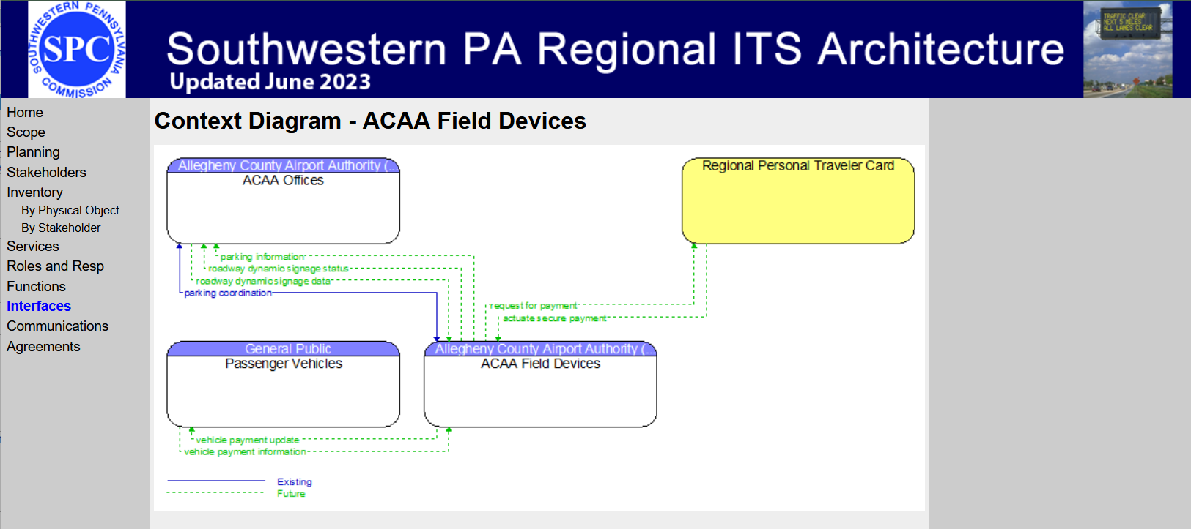
The context diagram will contain rounded boxes (either yellow or white with a blue heading) connected with information flows that have labels, directionality and a line style. A context diagram places the inventory element you are examining in the center of the diagram and shows all interfacing elements around it. The yellow rounded boxes indicate that no functions have been defined for that element in the ITS architecture, while the white with blue heading rounded boxes have at least one function defined. Usually, yellow rounded boxes indicate minor elements in the region while the white with blue heading rounded boxes indicate major elements in the region.
It is important to validate that the flows connecting the elements look correct (their name, direction and status (existing, future or planned). A flow is referenced by stating its source element, flow name and destination element. Some context diagrams may be very complex, in that case it may be better to print out the diagram, mark it up and provide it to the SPC.
You can also go to the “Interfaces” link on the left-hand menu to review individual interfaces. This is done by finding your element (which are displayed in a table alphabetically) on the left side of the table and selecting the corresponding hyperlinked Interfacing Element.
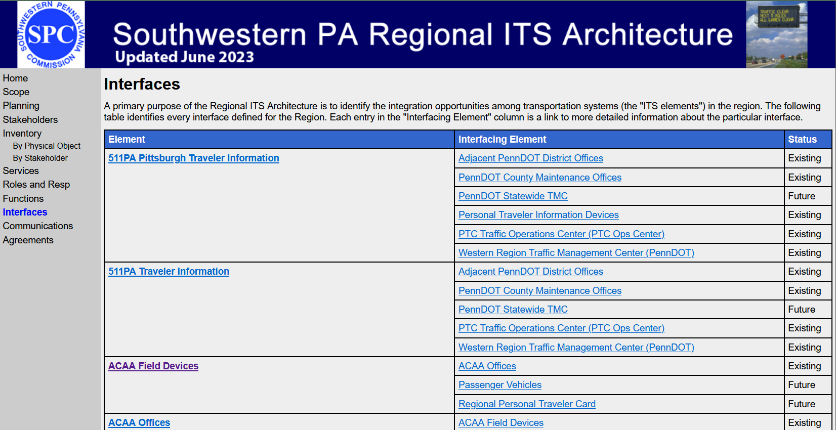
This will result in a simpler diagram that only displays the two elements and the information flows between them.
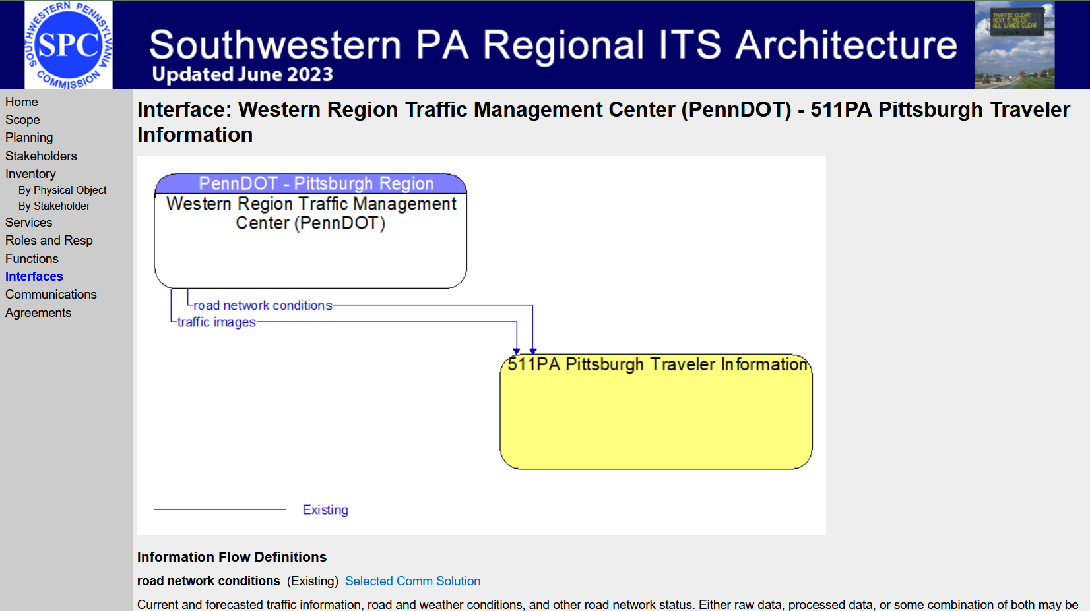

Agreements
An important aspect of a regional ITS architecture is capturing the institutional agreements between stakeholders for information sharing and shared control of devices. The agreements can be found again on the left-hand side of the website by selecting “Agreements” and reviewing the general agreements between stakeholders in the region. It is important to review the agreements to ensure that your agreements regarding your ITS are captured in the architecture. Note that the actual agreement is not found here, only a reference to the agreement.
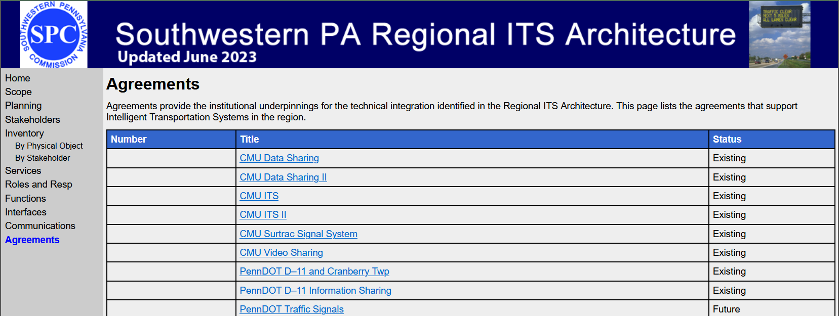

Services
It might help to explore the ITS services that your transportation systems or inventory are a part of. To review the Services that your elements are a part of, select the “Services” menu item on the left of the website. You will see a heading called Service Packages with a table listing the service packages included in the Southwestern Pennsylvania Regional ITS Architecture along with their status. The service packages are grouped alphabetically by category: CVO-Commercial Vehicle Operations, DM-Data Management, MC-Maintenance and Construction, PM-Parking Management, PS-Public Safety, PT-Public Transportation, SU-Support, ST-Sustainable Travel, TM-Traffic Management, TI-Traveler Information, VS-Vehicle Safety and WX-Weather.

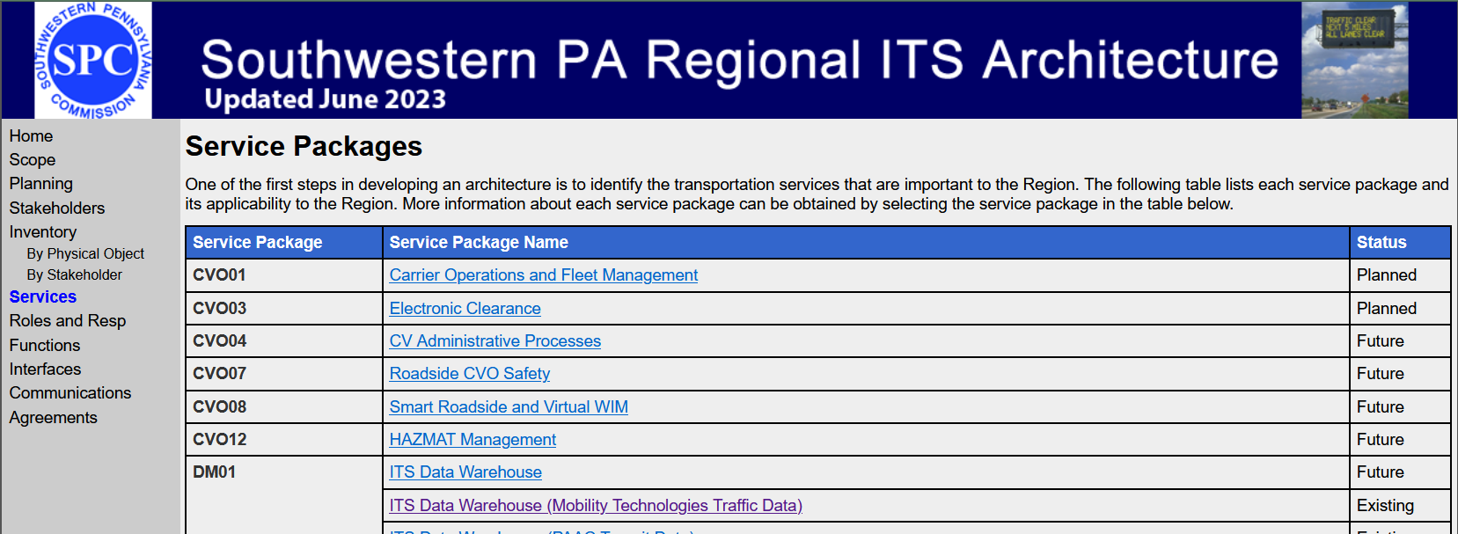
There are really two types of service packages, the first type is where there is only one service package name (second column) for a given service package ID (first column). These service packages are usually regional in nature and may contain your inventory elements so if you suspect that you perform that service make sure you click the service package name and see if it includes your element(s). It may be that your element is missing from a service package so you will need to report this. The second type of service package contains multiple service package names for the same service. For example, the PT01 Transit Vehicle Tracking service package shows separate names for BART, BCTA, Greene County DRT, MMVTA, POGOH, PRT, a catch-all name of Regional Transit Agencies and WCTA as well as WTA/Freedom. For these service packages you should select the one with your name or if your name isn’t included then select the general name. Verify that the elements are correct (they are all part of the service).
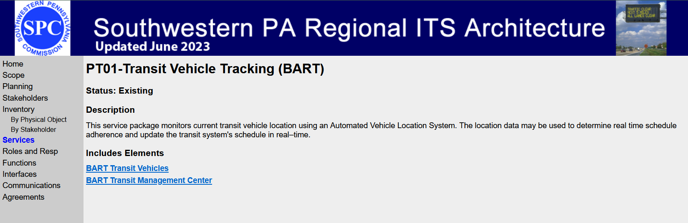

Additional Review
In addition to the above items, you can review the Planning, Roles and Resp and Functions sections of the website as they pertain to your ITS elements and services.

